How to setup the router for DHCP internet connection mode?
Model number: N151
There are five internet connection modes for the router. This article will guide you how to setup the router for DHCP mode and the steps as below.
Part 1:Connect the devices
Part 2:
Configure your computer
Part 3:Setup the router
Part 4:Check whether you can access internet
Connect the modem with the WAN port of the router, then connect your computer with one of the LAN ports of the router by a cable.
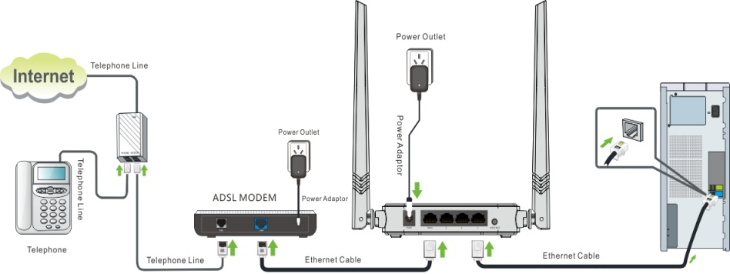
Attention: After connection the SYS light should be blinking, the WLAN light should be on or blinking, the WAN light should be on or blinking.
Open Network and Sharing Center. (Here is for windows 7, other operating system please click HERE.)
1 Click on Network Connection Icon on the system bar, then click on Open Network and Sharing Center.
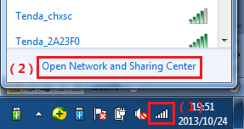
2 Click on Change adapter settings.
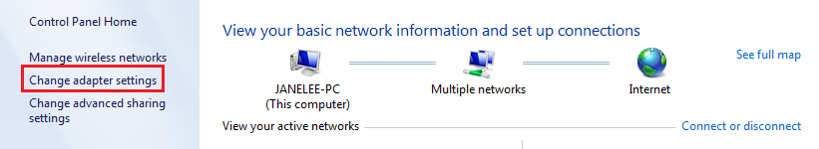
3 Right click on Local Area Connection, then choose Properties option.
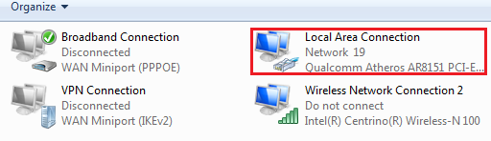
4 Double click on Internet Protocol Version 4(TCP/IPv4)
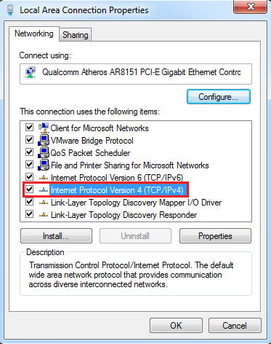
5 Choose Obtain an IP and DNS server address automatically and then click OK.
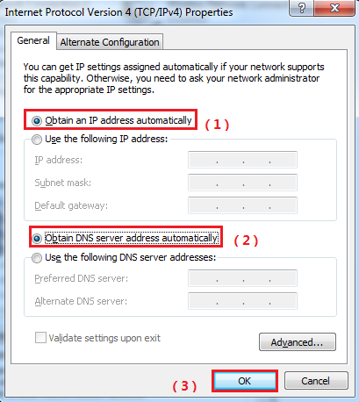
6 Also click onOK on the first Local Connection Properties window
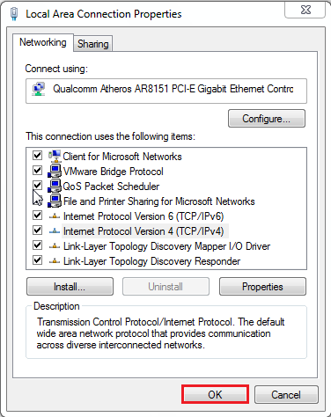
1Open a browser then type 192.168.0.1 in the Address bars, click Enter.
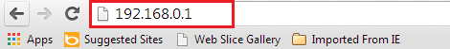
Note: If you cannot login the management page, please click HERE.
2Choose the DHCP option, set a Security Key, click on OK, then click on Advanced.
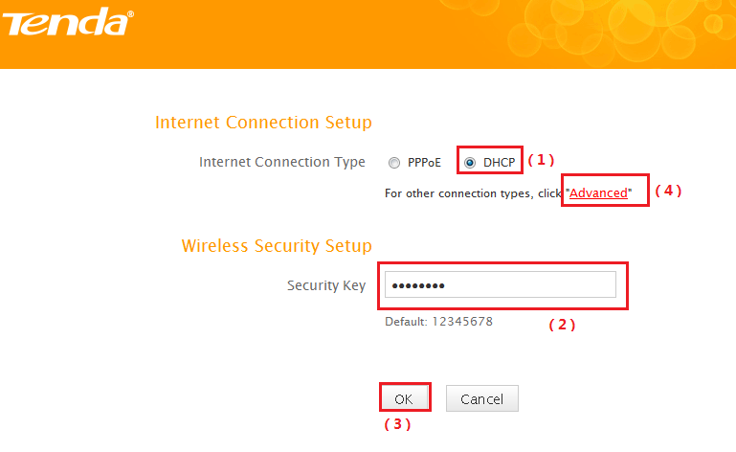
3Click on Tools, click on Reboot, then press the Reboot The Router button to reboot the router for refreshing the device info.
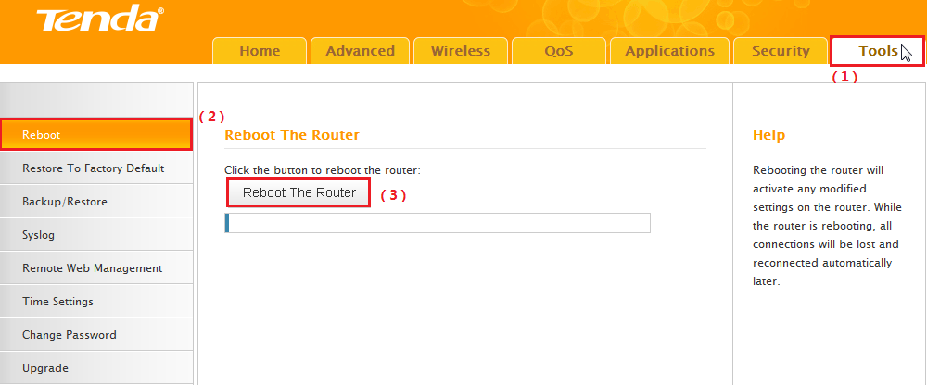
Click on Advanced then check the Status if the Status shows Connected that means you can access internet, please check.
